**TheBlackHoods 6 – TBH6 (Musician/Band)**

**Feasibility Report**

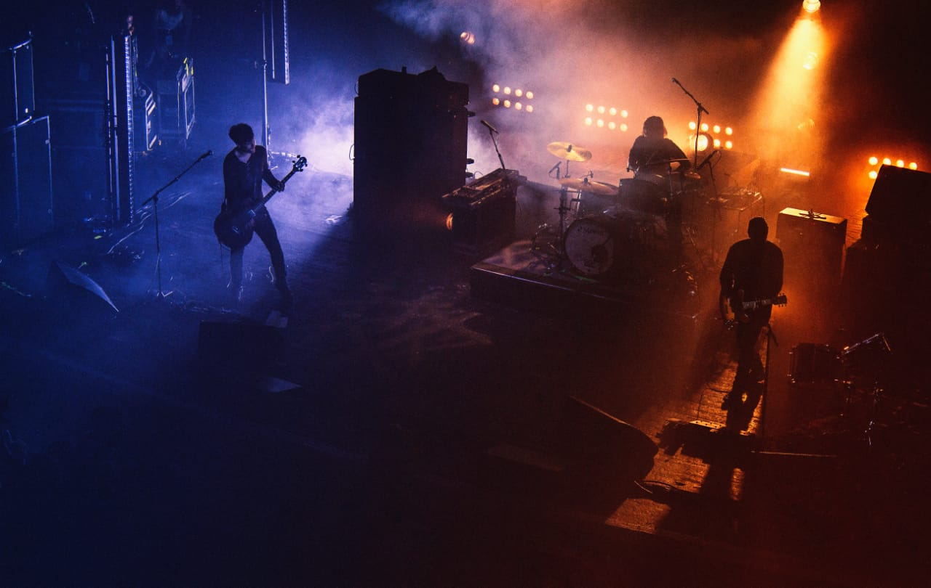

**TABLE OF CONTENTS**

1. **The Client** ………………………………………… **3**
2. **Team Members**…………………………………… **3**
3. **Statement of the task to be undertaken**….…….... **4**
4. **Preliminary Requirement Analysis**………....…… **4**
5. Functional Requirements…………….… **5**
6. Non-functional Requirements…………. **5**
7. **Suggested Deliverables**…………………………… **6**
8. **Process to Be Followed**…………………………… **7**
9. Iterative Refinement Process………...… **7**
10. **Outline Plan** ………………………………………. **8**
11. Activities & Milestones ……………….. **8**
12. **Visibility Plan** …………………………………..… **9**
13. Gantt chart………………………...…… **9**
14. **Business Considerations**……………………….… **10**
15. **Risk Analysis**……………………………………... **11**
16. **Technical Requirements**…………………………. **12**
17. **The Client:**

The BlackHoods 6-TBH6 is a newly formed band consisting of youngsters who are very passionate about music. They are an exceptional band with members having different skills such as Guitarists, Leads, Bassist, Vocalist, Darbooka player, and so. The issue which is currently being faced by them is that they are struggling from communication gap between them and their fans. They don’t have any proper website and they are not getting proper reach through different social media platforms. So, they have decided to become more professional and start a website where their fans can search for their upcoming events, albums, singles, announcements, etc. Where the fans can also learn about the struggles and hard work of their favorite band members and their accomplishments.

1. **Team Members:**
2. Muhammad Khizer Atiq (41374)

[khizeratiq1@gmail.com](mailto:khizeratiq1@gmail.com)

1. Muhammad Nauman Saleem (41307)

[noumansaleem1999@gmail.com](mailto:noumansaleem1999@gmail.com)

1. Zaid Bin Hameed (41086)

[zaidhameed170606@gmail.com](mailto:zaidhameed170606@gmail.com)

1. Javeria Salim (42300)

[javeriasalim4@gmail.com](mailto:javeriasalim4@gmail.com)

1. Muhammad Ahmed (41396)

[ahmed.khatri.908@gmail.com](mailto:ahmed.khatri.908@gmail.com)

1. **Statement of the task to be undertaken:**
2. **Preliminary Requirement Analysis:**
3. **Suggested Deliverables:**
4. **Process to Be Followed:**

**Iterative Refinement Process:**

For this project we will be using iterative refinement process because we want our clients **(The BlackHoods 6)** to be satisfied with the final result and another reason is that our client is confused between different types of websites. So by using iterative refinement process we will first create a prototype using the basic requirements given by the clients then with the multiple iterations of reviewing the prototype with client we will finalize the website with the satisfaction of our client. In this process or iterative refinement we might have to redesign the prototype on the basis of the feedback of client. With website reviewed with the client at every step of the iteration our team will be adding different modules to the website which will be gallery, news, user feedback panel, page to display information of every member of the band, previous music record of the band and other functionalities as advised by the client.

At each milestone our team will present the latest version of the website to the client so they can test and evaluate the website and give feedback. Website won’t be final until our client is fully satisfied with the result.

**The Final Result**

The final result will contain all the features and modules on which both client and we have agreed upon.

1. **Outline Plan:**

* **Milestone 1 :** **(Project Proposal)** Our first ever milestone was the project proposal which we have already submitted. In project proposal we have mentioned who is our client and what we are going to develop. And how and when exactly we are going to do that.
* **Milestone 2:** **(Prototype)** In second milestone we will develop a prototype according to client’s requirements. As soon as the prototype is ready we will share it with client so we can have client’s feedback which will help us to work in next step of development.
* **Milestone 3:** **(User Interface)** After have a concrete idea about what client exactly wants we will start working on interface and other client side modules of the website. And then again sharing the latest model of the project with client for feedback for next step.
* **Milestone 4:** **(Discussed Modules)** After the interface is approved from client, we will start working on the modules which were discussed in proposal.
* **Milestone 5:** **(Testing)** Once every module has been developed and shared with client then our team will test the website for the last time with every possible input from user.
* **Milestone 6:** **(Release)** After the successful test on the website we will release the website for public use.

1. **Visibility Plan:**

**Gantt Chart:**

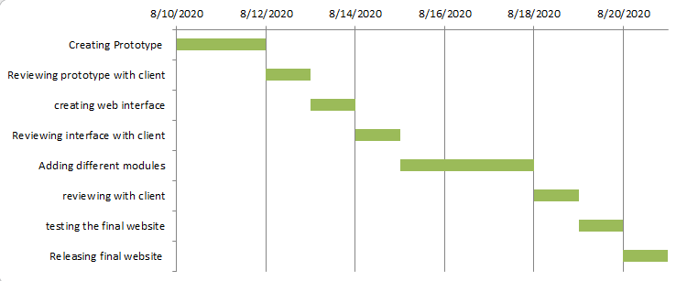

1. **Business Considerations:**
2. **Risk Analysis:**
3. **Technical Requirements:**

**Survey Questions:**

**Survey Questions From Muhammad Khizer Atiq(41374):**

1. Are you okay if our team frequently asks for feedback? Because the process we are going to use for this project requires a lot of feedback from you?
2. Are you satisfied with the process for the development of this project?
3. Or do you have any other specific process for the development of this project?
4. Are you satisfied with the milestones we have set or you want some changes in them?
5. Is Gantt Chart clear to you?